How to Debug Multithreaded Programs in C#

**Working with multiple threads in console applications**In this section we will see a simple console application, were I created 2 threads.

1. **namespace** DebugThread
2. {
3. **class** Program
4. {
5. **static** **int** i = 0;
6. **static** **void** Main(**string**[] args)
7. {
8. Thread T1 = **new** Thread(MyMethod);
9. Thread T2 = **new** Thread(MyMethod);
10. T1.Start();
11. T2.Start();
12. Console.Read();
13. }
14. **static** **void** MyMethod()
15. {
16. **for** (**int** i = 0; i < 10; i++)
17. {
18. i++;
19. Thread.Sleep(5000);
20. }
21. }
22. }
23. }

**Open the Thread Window**

**Step 1**Insert a Breakpoint in the code.   
  
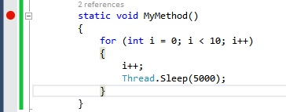

**Step 2**Run our application (press F5).

**Step 3**

Click on the Debug menu and choose the **windows**option then select Threads as shown in the following image.  
  
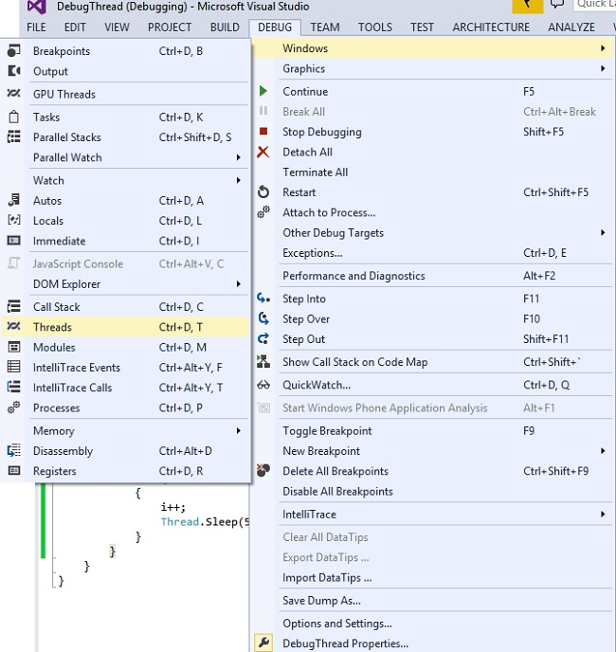

**Working with Thread Window**

Now let's have a look at the Thread window.  
  
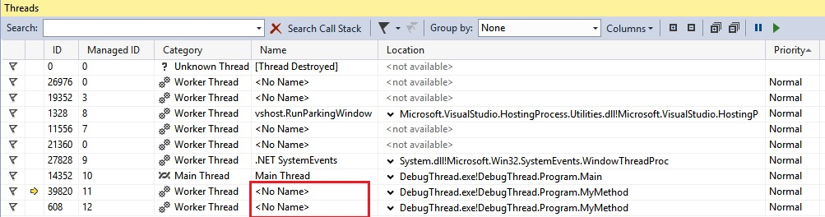  
  
As in the preceding image we can see the thread having no name. So, let's assign the name of the thread.  
  
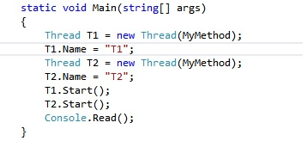  
  
Now we can see the thread name in Thread Window.  
  
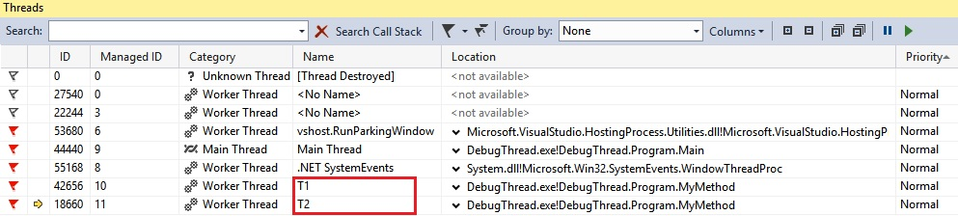  
  
**Flagging and Unflagging Thread**

* Go to the Debugging Location toolbar and click the Thread list and see how many threads appear in the list.
* Go back to the source window and right-click the Thread marker again.
* On the shortcut menu, point to Flag and then click the thread name and ID number.

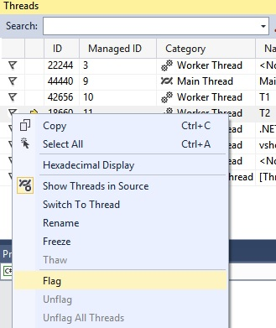  
  
**To unflag threads**  
On the Threads window, right-click the line corresponding to the flagged thread. A shortcut menu is displayed. It has options to Unflag and Unflag All.  
  
To unflag the thread, click **Unflag**. Or click the Red flag icon.  
  
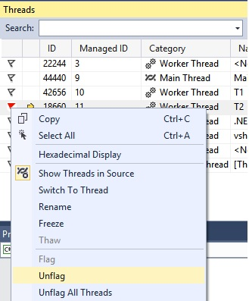  
  
**To freeze and Thaw threads**Freezing a thread will suspend its execution, in the debugging process. We can say Freeze has suspended the process and Thawing resumes the process. By Freezing and Thawing threads (suspending and resuming), we can have control of the threads running during the debugging process. It helps us when we are solving bugs related to concurrency.  
  
In the Threads window, right-click any thread and then click **Freeze**.  
  
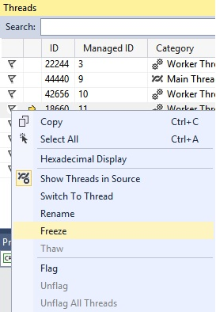  
  
Look at the active thread column. The pair of vertical bars now appear there.   
  
Right-click the frozen thread and then click **Thaw**.  
  
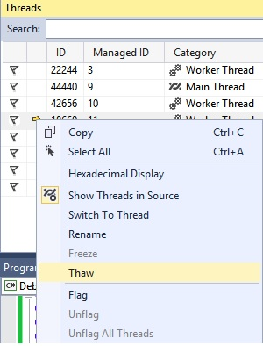  
  
The active thread column and the Suspend column change.